Payment Method: Cash, Check, or Money Order due upon order
Billing Information: Type or print clearly
Name Date
Address
City State Zip
Email Address
Phone Number

Hero Info: Type or print clearly
Rank/Name
Branch of Service
Years Served _____
Note: Each line contains space for about 16 characters. Over 16 characters the print gets smaller.
□ Photo of Hometown Hero is attached (photo will be returned to you)
□ A digital photo will be emailed to RedLionHeroes@gmail.com

List any banners which should be grouped together ____________________
Review proof of Hero’s information carefully. No changes after order placed.

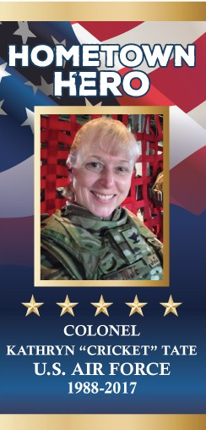
Make checks payable to Red Lion Borough (Memo Line – Red Lion Hometown Heroes)
Mail or drop off application, photo, & payment to Red Lion Borough office,
Attn. Stacy Burke, 438 E. Lancaster St., Red Lion, PA 17356
Contact the RL Hometown Hero Committee at RedLionHeroes@gmail.com for an application or if you have any questions – Thank You!
Red Lion Hometown Heroes

Honor the men and women who have served and those currently serving our country today!

$300 each

